

**CAPSTONE PROJECT REPORT**

**Report 1 – Project Introduction**

– Hanoi, Jan 2023 –

**Table of Contents**

I. Record of Changes 3

II. Project Introduction 4

1. Overview 4

1.1 Project Information 4

1.2 Project Information 4

2. Product Background 4

3. Existing Solution 5

Wattpad 5

4. Business Opportunity 7

5. Software Product Vision 8

6. Project Scope & Limitations 8

6.1 Major Features 8

6.2 Limitations & Exclusions 8

# I. Record of Changes

|  |  |  |  |
| --- | --- | --- | --- |
| **Date** | **A*, M, D** | **In charge** | **Change Description** |
| 09/01/2024 | A | Report Create | Create basic items of the report |
| 15/01/2024 | M | Modify Feature | Modified features content |
|  |  |  |  |
|  |  |  |  |
|  |  |  |  |
|  |  |  |  |
|  |  |  |  |
|  |  |  |  |
|  |  |  |  |
|  |  |  |  |
|  |  |  |  |
|  |  |  |  |
|  |  |  |  |

*A - Added M - Modified D - Deleted

# II. Project Introduction

## 1. Overview

## 1.1 Project Information

* Project name: Genesis - Easy Publishing
* Project code: EP
* Group name: SEP490_G14
* Software type: Web Application

## 1.2 Project Information

|  |  |  |  |
| --- | --- | --- | --- |
| **Full Name** | **Role** | **Email** | **Mobile** |
| Pham Duc Thang | Supervisor | thangpd10@fe.edu.vn | 0912656836 |
| Nguyen Quang Huy | Leader | huynqhe163812@fpt.edu.vn | 035670536? |
| Pham Duc Duy | Member | duypdhe16030@fpt.edu.vn | 0943678695 |
| Pham Chu Duong | Member | duongpche163153@fpt.edu.vn | 0974018759 |
| Nguyen Duy Nam | Member | namndhe163785@fpt.edu.vn | 0386033163 |
| Nguyen Quang Nguyen | Member | nguyennqhe151209@fpt.edu.vn | 0399644201 |

## 2. Product Background

In the rapidly evolving landscape of story publishing, traditional methods have presented challenges for both authors and readers. For authors, The author begins by writing the book, or at least part of it. This process can take months or years depending on the author's writing speed. Moreover, the process of reviewing and approving with traditional publishers also takes time. After completing the manuscript, the author sends his/her portfolio and manuscript to traditional publishers for review - typically including a description of the content, a description of the work, information about the author, and chapter samples. The publisher reviews the manuscript and makes a decision on whether to accept or reject publication. This process can last from a few weeks to a few months. Another concern is the printing stage : Before your story is printed, the author, along with the publisher's editor, initiates the editing and compiling process to refine the content. They collaborate with design teams to create the book cover and layout the content. And finally, The printed books are distributed to bookstores, distribution agents, and online stores. The publisher executes a marketing strategy to promote the book, which includes advertising campaigns, book signing events, and online promotion. At the same time, readers may find themselves in a situation where they invest in a story but end up not enjoying the wasteful content. More deeply, it is also a cause of environmental pollution.

To overcome these challenges, our proposed software solution offers a revolutionary approach to story publishing - Genesis. Authors - professional or non-professional - can approach writing stories online. The application also gives them the flexibility to publish their work such as publishing chapters one by one, minimising printing costs and overcoming the complicated procedures of traditional publishers. Another thing is that authors can receive the earliest feedback and contributions from readers so that they can absorb and edit with the work in the next chapters or simply have more motivation in writing. From the above will solve the problems that the author encountered in the traditional method.

For readers, they are terrified of wasting money on an uninteresting storybook that does not meet their expectations. Therefore, this platform will allow readers to be selective and invest in content they find attractive: watch the first few chapters. If they are interested in the composition, they can buy the whole book or buy the chapter. Along with that they can read the earliest releases without having to wait publication time.Moreover, putting reading stories on digital platforms will be accessible by many different methods such as phones, computers, tablets with internet connection. Thereby meeting their entertainment needs.

## 3. Existing Solution

### Wattpad

Wattpad link: <https://www.wattpad.com/>

Wattpad is an online social reading platform that breaks down barriers between readers and writers. It encourages users to create and share their own stories in all genres from teen fiction to poetry to action, adventure and more.

Created in Canada in 2006, Wattpad stories range from those in the public domain to those developed by local users who may then go on to publish for wider audiences. This means that teens and young adults can write and know that their work may be able to reach a lot of people. As such, it’s important they understand how to stay safe on Wattpad.

More than 90 million people use the platform to read and write, spending over 23 billion minutes per month engaged in different stories. 90% of these are users aged 13-40-years-old and many of the writers are older teens or young adults.

Wattpad has a variety of features to categorise their stories and different types of content, which can help users avoid inappropriate content or find the exact kind of topic they want to read and write about.

* **Tagged content** – Writers who publish on Wattpad can add tags to their story that work similarly to hashtags on social media. Users can then search those tags to find the kinds of stories and types of content they are interested in reading. These tags also tell users whether the content is appropriate for them and should be tagged accurately. Users can add blocked tags to avoid seeing specific content.
* **Rating a story** – You can set an age ranking as either ‘Mature’ or for ‘Everyone’. Wattpad’s mature or ‘new adult’ stories are given an age ranking of 17+. However, users under this age still have access to these stories, so it's important to discuss with your child what is appropriate for their age and why. Learn more about inappropriate content here.
* **Reading list** – Users can save stories they enjoy to their reading lists for easy access. These are publicly displayed on user profiles, which can create connections or talking points between users.
* **Writing in-app** – Wattpad is available in-browser or via app on your mobile phone. Users with the mobile can essentially write anywhere at any time rather than waiting until they have a computer in front of them.
* **Story notifications** – If you follow a story or author, you can receive push notifications on your mobile or to your email address when content is updated. In essence, users can read the story as it’s created rather than waiting until the whole work is completed.
* **Wattpad paid stories** – Users can utilise this feature and earn money from their writing. Similar to virtual gifts on streams or Patreon, readers can support their favourite Wattpad books and writers by donating Coins. These must be purchased with real currency through Apple or Google Play accounts and should be monitored by parents and carers.

With the features of Wattpad gives us a lot of advantages:

* A free platform accessible to anyone with an internet connection.
* Having a large and engaged community of readers who actively seek out new content.
* Writers can publish their stories chapter by chapter, which allows them to build an audience and get feedback before they finish their stories.
* Wattpad allows readers to leave comments and interact with writers directly.

## 4. Business Opportunity

There is a compelling business opportunity to introduce a pioneering digital platform that will revolutionise traditional story publishing. The platform solves the challenges authors face, providing risk mitigation through increased publishing and streamlined web processes. For readers, it offers flexibility in viewing content, ensuring they only invest in what they find engaging. With interactive features, copyright protection, and innovative sales policies, the platform not only changes the author-reader dynamic but also contributes to environmental sustainability. The business aims to capture a significant market share by redefining the digital publishing landscape. To highlight the product, my team provided something that meets user needs with the following features:

|  |  |  |
| --- | --- | --- |
| **Feature** | **Authors** | **Readers** |
| **Continuous Writing and Reading Experience** | It will be very difficult for the author to complete a book or a season of that book. However, Genesis allows them to publish a story even if it's incomplete and they'll continue to write and publish chapters and sequels of that series in the future. | Instead of having to wait for the story to be published, readers have the flexibility to read chapters in a seamless manner, promoting an immersive experience. |
| **Increased Accessibility and Interaction** | One thing that authors are very concerned about is whether readers receive their products or how their products are evaluated. So allowing readers to comment and rate will somehow motivate them. In addition, we also allow autograph activities - print an autograph copy and send it to the reader. | If you just read it, it will be very boring and not interesting to users. Therefore, we provide some functions so that users can interact with each other or users with the author: raise issues for everyone to discuss, rate and discuss the story or a certain chapter. |
| **Innovative Sales Policies** |  | A variety of purchasing options, including buying the entire story, purchasing individual chapters, or pre-ordering, motivate both authors and readers. |
| **Content Moderation Mechanism** | A rigorous content moderation system ensures that the platform maintains a high standard of quality and adheres to community guidelines. |  |

## 5. Software Product Vision

Imagine a vibrant online story platform where authors effortlessly publish chapters, connect with readers through digital signatures and launch events, and receive real-time feedback. Authors benefit from diverse sales options and robust copyright protection. Readers enjoy a flexible reading experience, purchasing individual chapters without committing to an entire story. They actively engage with authors, share experiences through reviews, and appreciate diverse sales policies. Trusting in content moderation and security measures, readers find a dynamic and secure space to explore and enjoy digital literature. Together, authors and readers shape a symbiotic digital landscape, redefining the traditional author-reader relationship in the era of interactive and secure online storytelling.

## 6. Project Scope & Limitations

### 6.1 Major Features

FE-01: User and Access Management

FE-02: Publishing Management Center

FE-03: Interactivity

FE-04: Reader interface

FE-05: Transaction

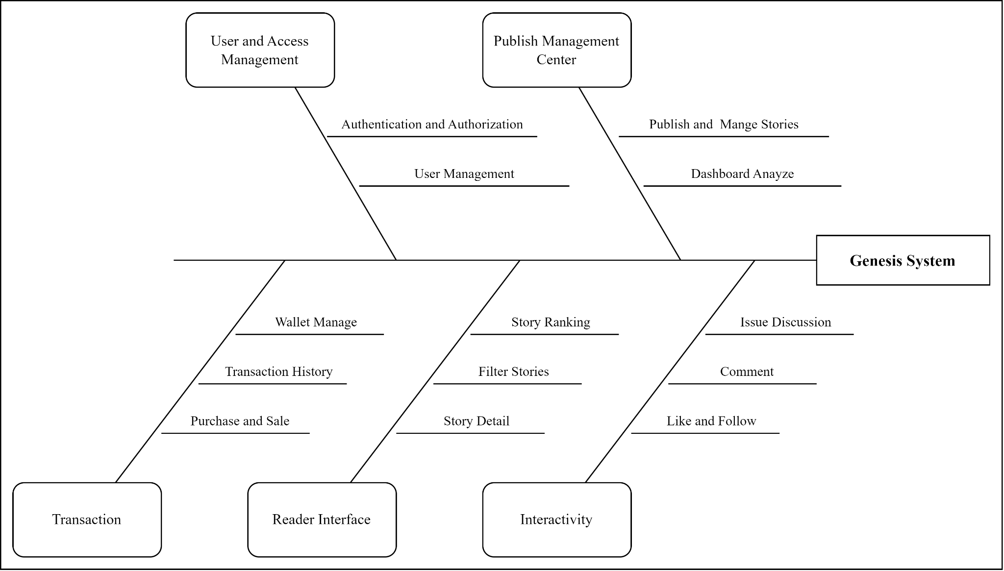

### 6.2 Limitations & Exclusions

LI-1: The quality of user-uploaded content can vary widely. Some stories may be poorly written, contain errors, or be inappropriate.

EX-1: Genesis won’t be liable to you for any damages that arise from your use of, or in connection with, the Services and any content.